Isolate a problem
TIP: Find the problematic code, describe the resolution, and optionally return to the client the fixed code sample.
I have just started using jQuery but it seems rather confusing. Until now I was using the native JavaScript document API without any issues but with jQuery I cannot do even simple tasks like subscribing to the click event of a button. I have prepared a sample that demonstrates what I mean. You can find it attached to my message.
Your help will be appreciated.

Solution

Hello John,

I understand your confusion. The native JavaScript has its use but jQuery is way more powerful and easy to use when you become familiar with it. I will explain you the differences in a few sentences and examples.
You are trying to use “addEventListener” which is the vanilla JS function. I think you just made a little mistake because you typed “attachEventListener”. This is not the problem since none of the functions will work with jQuery so let’s go to the example.
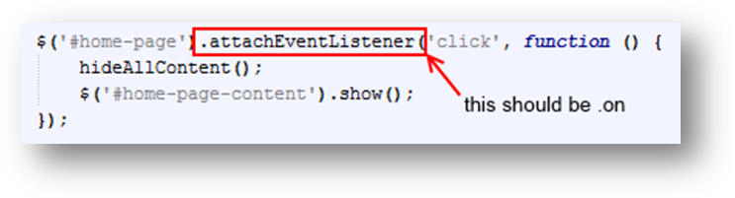
You could use .on() or .click() functions from jQuery. You should just replace “attachEventListener” with one of the above and the code will work just fine.

The more general approach to attach an event in jQuery is to use .on() function and in the brackets you could write the event you are about to catch. (General approach).
However if you want to catch “click” event you could use .click() function in jQuery. I would personally recommend using the general approach since it is more robust and provide flexibility when changing events. (Click event example)

Examples: (just double click on the code if you want to copy it):
- General approach example
Link to the documentation:
http://api.jquery.com/on/

- Click event example
Link to the documentation:
https://api.jquery.com/click/

Best Regards
Martin Veshev

